WEBER COUNTY PLANNING DIVISION

Administrative Review Meeting Agenda

February 12, 2020

1:00 to 2:00 p.m.

- LVP110119: Consideration and action on a request for final plat approval of Pole Patch Phase 3 Subdivision, consisting of three lots, located at approximately 5080 Jessie Creek Dr. in the Agricultural (A-1) Zone. Spencer Bradley, Applicant (Scott Perkes, Presenter)

- Adjournment

The meeting will be held in the Weber County, Breakout Room, in the Weber Center, 2nd floor 2380 Washington Blvd., Ste 240., Ogden, Utah unless otherwise posted

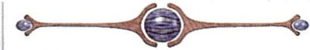

In compliance with the American with Disabilities Act, persons needing auxiliary services for these meetings should call the Weber County Planning ·Commission at 801-399-8791

